Education Research Project (ERP)  Student Proposal |  |  | 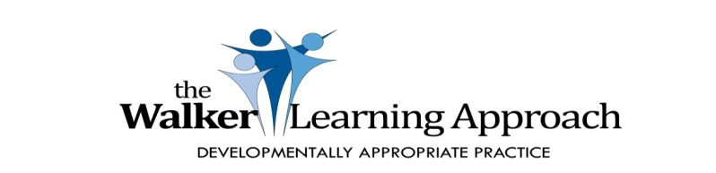
Student Name: |  | Term: |  | Date:
Project Scope
Major subject focus | Name the specific area of science you aim to explore eg chemical science, biological science, Earth and space science or physical science.
Key interest area: Why are you interested? | Explain why you have chosen this particular area.
How does your interest link to the subject focus and Learning Intentions? | Justify how the Learning Intentions and Success Criteria link to your interests.
What are you hoping to find out? | Identify some key points highlighting what you are hoping to establish, find out more about or check something that you think you already know. In this section you must pose a question or a hypothesis that you wish to explore and test.
Suggested timeline | The timeline for this project is 4-5 weeks. This is non-negotiable.
In which ways will you present your project? | Record how you intend to present this project. It may involve the completion of more than one piece of work.
What aspects of literacy will be included in your project? | The project must contain at least one aspect of literacy. It may be a specific genre of writing, include text references or involve a handwritten piece of work.
What aspects of numeracy will be included in your project? | The project must contain at least one aspect of numeracy. It may be some data collection, graphing or some other mathematical concept integrated into your project.
Are there any other subject areas or skills that will be included in your project? | Explain any other subject areas that you wish to include in your project.
List your personal goals for this project. | List some personal goals or specific skills that you wish to achieve during this project. It may include adhering to timelines, remaining focused or working independently.
What skills do you already have that will assist you in this project? | Reflect on the strengths that you have and list them. Explain how they may assist you when you are completing this project.

